Department: Electric. Subject: Power electronics (E1336)
3rd year Medical Second Term (2016-2017)
Sheet (3)

- For the circuit in Fig.(1) , the supply voltage has a peak value of 250V , and frequency of 50 Hz. If the load is R=100 Ω,
- draw the waveforms of output voltage, output current, diodes current , diodes voltage, and input current.
- determine the average load current , output DC power, efficiency of rectification, ripple factor of output voltage.
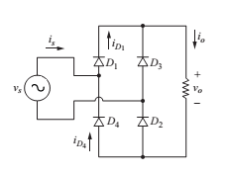 Fig.(1)
- For problem (1), calculate the average current and r.m.s current of diodes.
- The circuit in Fig.(2) has a source of 240 V rms at 60 Hz, E = 20 V, R= 10 Ω , L=5 mH. If the firing angle =60°, determine the whether the load current continuous or discontinuous?
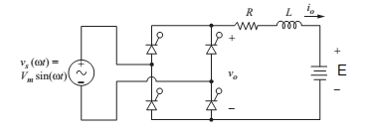
Fig.(2)
- In problem (3), calculate the average output voltage and current, also draw the waveforms of voltages and currents (supply, load ,and thyristors).

- Repeat problem (4), If the source (E =0), and the firing angle =20°.
- If the load in Fig.(2) is highly inductive load with E= 100 V, R=30 Ω. Determine the delay angle such that the power absorbed by the dc source is 1000 W . Also, calculate the average output current, output voltage, and input source current.
- Repeat the problem (6), if a freewheeling diode is inserted in the circuit in Fig.(2).
- For the circuit in Fig.(3), the load is highly inductive load such that the output current is 10 A, the supply voltage has 220 V , 50 Hz, and an inductance =0.1 m H. Calculate the overlap angle (u), output average voltage. Also, draw the voltage and current waveforms.
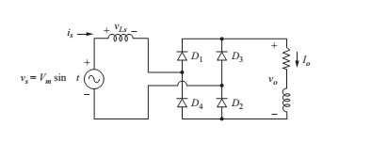
Fig. (3)

